What I have already done:

For this project, I have already written the basic structure for the Texas Hold-Em game. I have created the structure for the Board, Card, and Deck class, and I am now currently filling out the win conditions for the Board class. For the win conditions, I decided to test for 5 conditions, if it is a two, three, four, straight, or flush. All of the different scoring conditions are combinations of these conditions. I also have a deck class so there won’t be two same cards in play at the same time (that ruins the whole game, because if there are copies of the same card on the board, then there are cases where two or more players can have the same value hand, like the same full house or the same straight flush). Below is a basic diagram of how my game structure will be.

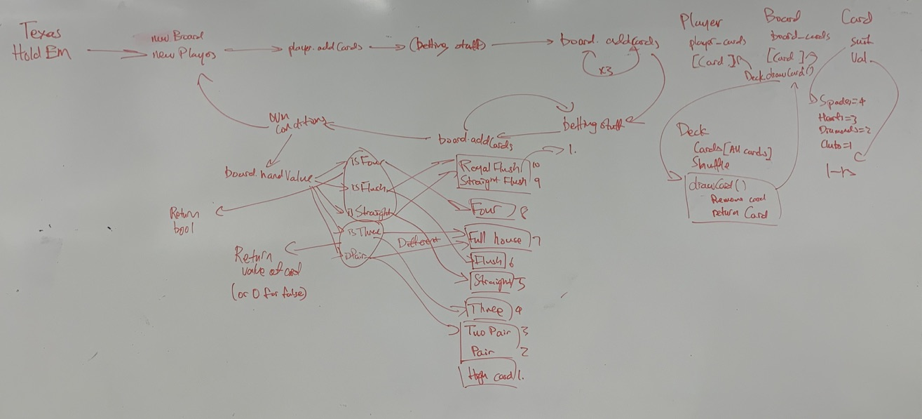

What I plan on doing:

For the winter term, I plan on finishing the game structure (to the point where it can be played in the terminal). Then, if I have time, I might use a graphics library to make it an actual game. However, my main goal is to write a program that plays the game against the human player. I can do so by calculating the possibilities for each outcome using the known information (what the program’s hand is, what the cards on the board are). I can also use a randomizer for this game, as I can randomly generate different boards and see what the average value for a hand is, then use that information to decide whether to raise, call, or fold. Writing this will take probably all of spring term.